**Graphs Practice**

Names: **Shang Nelson**

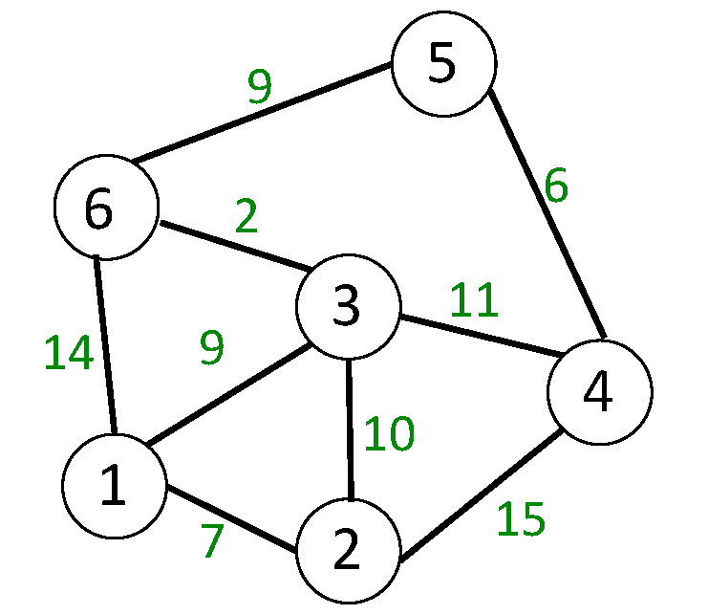

1. What are the edges of the given graph?
   1. **5-6, 6-5, 5-4, 4-5, 3-4, 4-3, 3-6, 6-3, 3-2, 2-3, 3-1, 1-3, 4-2, 2-4, 2-1, 1-2, 1-6, 6-1;**
2. What are the vertices?
   1. **5, 4, 6, 3, 2, 1;**
3. Is this directed or undirected?
   1. **Undirected**
4. Is this weighted or unweighted?
   1. **Weighted**
5. Is the graph above connected or not?
   1. **Yes, as there is at least 1 path from every node to every other node.**
6. What is the lowest cost path from 1 to 5?
   1. **5-6-3-1**
7. Give an example of a cyclic path within the graph
   1. **3-1-2-3-1-2-3-1-2-....**
8. Is there an adjacency from 1 to 6? **Yes**
9. Is there an adjacency from 1 to 5? **No**

Draw an adjacency list and an adjacency matrix for the above graph

| **Adjacency List** | **Adjacency Matrix** |
| --- | --- |
| 5 -> 6, 4  6 -> 3, 1, 5  3 -> 6, 1, 2, 4  4-> 5, 3, 2  2 -> 1, 3, 4  1-> 6, 3, 2 | |  | 1 | 2 | 3 | 4 | 5 | 6 | | --- | --- | --- | --- | --- | --- | --- | | 1 |  | 7 | 9 |  |  | 14 | | 2 | 7 |  | 10 | 15 |  |  | | 3 | 9 | 10 |  | 11 |  | 2 | | 4 |  | 15 | 11 |  | 6 |  | | 5 |  |  |  | 6 |  | 9 | | 6 | 14 |  | 2 |  | 9 |  | |

Think of a real life scenario that could be modeled with a directed graph.

Bank debts. If it hasn’t been received by the loaner then that would be a path there, and when it needs to be paid back it could be represented as a path directed back to the bank.

Think of a real life scenario that could be modeled with an undirected graph.

Transactions of goods at stores based on the cashiering station that it passed through.

**Graph Algorithms**

Observe the graph Weighted Graph.

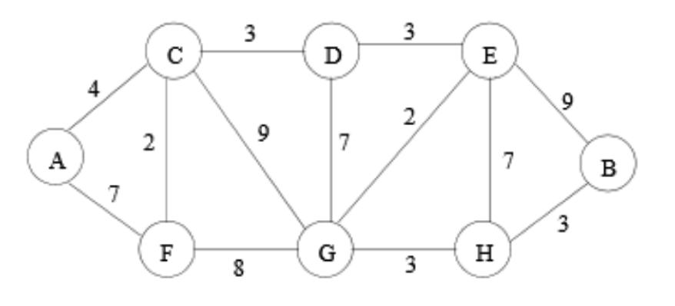

1. Starting from A, what is a possible order of nodes that would be visited with a Breadth First Traversal?
   1. A
   2. F, C
   3. G, D
   4. H, E
   5. B
2. Starting from A, what is a possible order of nodes that would be visited with a Depth First Traversal?
   1. A, F, G, H, B, E, D, C
3. Calculate the Shortest path from A to B using Dijkstra’s shortest path algorithm.
   1. A, C, D, E, B